**7) Test the performance of a website or application. This might involve testing how quickly pages load, how long it takes to complete certain actions, and verifying that the website or application can handle a large number of users.**

Here the validation of navigating one page to another page functionality and able to find the information and add the product into the cart without any loading or delaying issue.

Note: performance of the amazon application works fine while high number of users using on it.

**Adding items to cart.**

Adding the products into cart by selecting and click on add to cart.

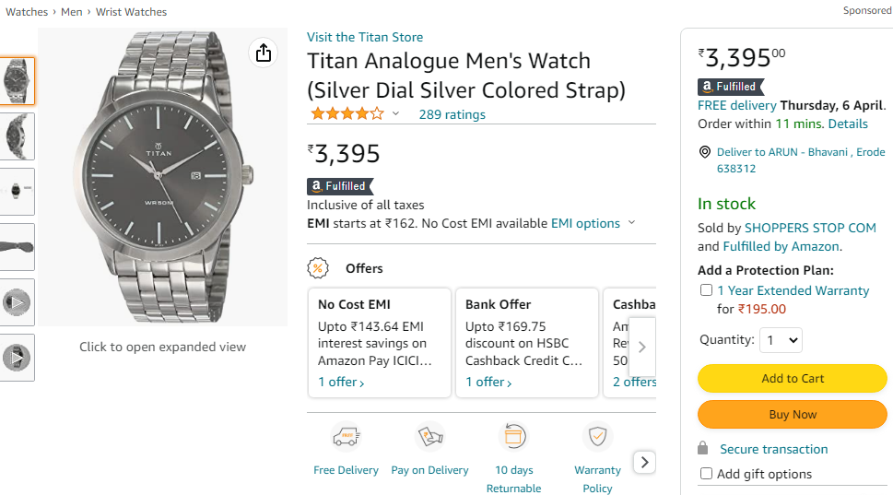

**Adding/Selecting shipping address.**

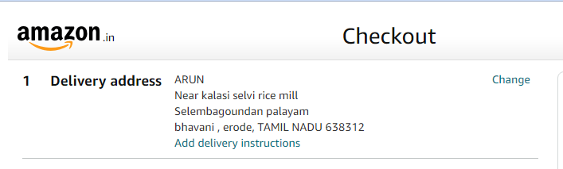

Selecting the product shipping address regarding needs.

**Entering payment details.**

Selecting and entering payment details of the order**.**

